So recently there are some updates happened in React native
and in this lesson we will discuss these changes in detail
This lesson is very important because if you are working in React Native then you will know how it worked previously and now what are the changes in it and How it will work in future
This lesson is important for interviews because if there are some changes happened in a library or Framework or Technology then the question related to those changes are asked mostly and what are the new changes in latest version
Previously the version of React native was 0.70 but now it is 0.71
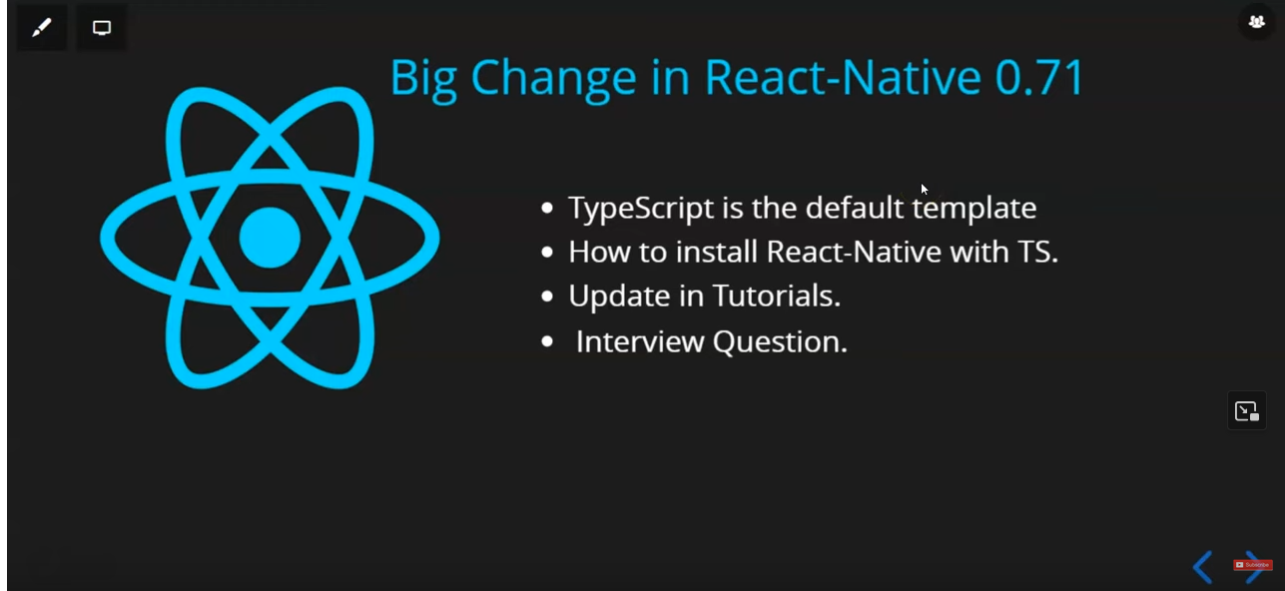
The big change that happened that whenever you install the React native application then it will be installed with typescript by default previously it was Javascript
So do we need to learn Typescript?
Can we not use Javascript with React Native?
we will answer it all but before we see React native documentation
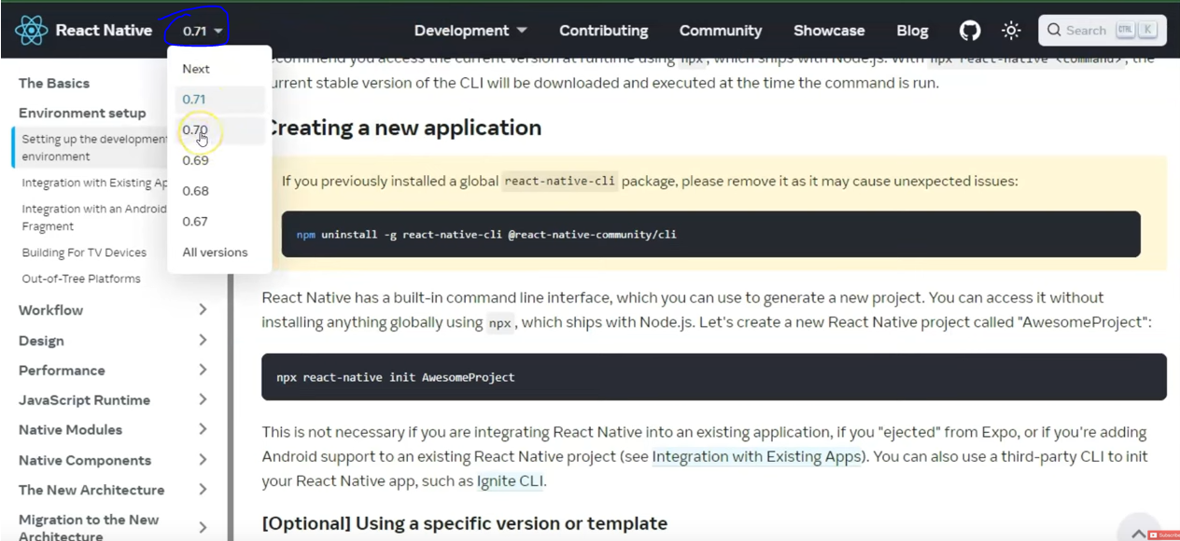
In React Native doc you can go to marked area to see the list of different versions of the React native if you click on any of the option and then see the documentation according to that version
In Blogs as shown above you can see different blogs for different version by choosing version in side menu
You can see in 0.71 Typescript by default ...
Whatever changes we will discussed is according to new version came a year go may be these changes may be removed or remained i don't know.
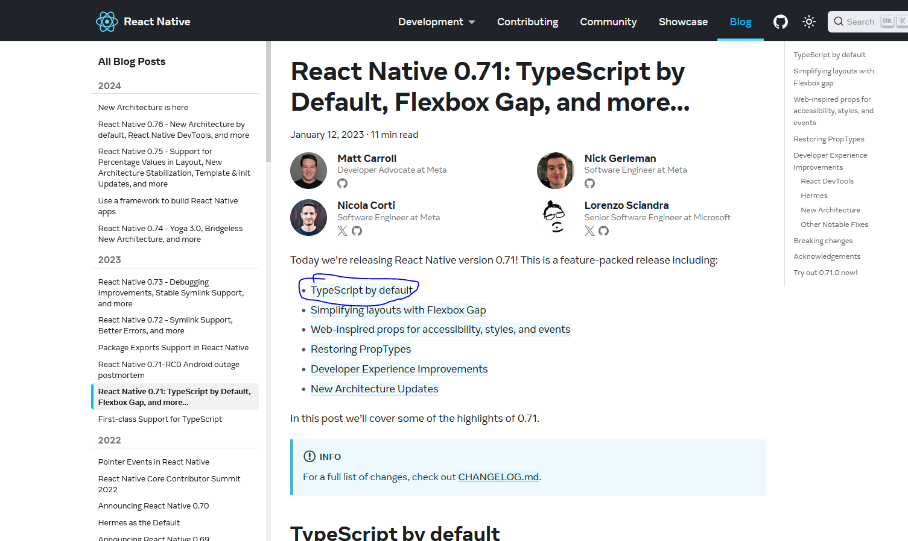
Teacher will tell us about Flexbox in another lesson where we will what are the changes happend in coding but for now in flow and archtecture(I don't know) we are understanding this
So click on the first link as marked above to reach Typescript by default topic.
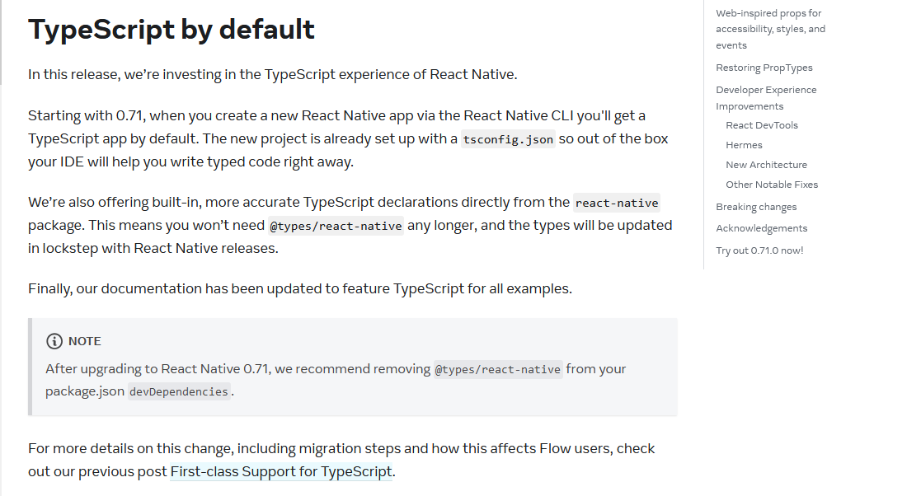
Teacher says if you read above text then you will understand everything
Now they are saying that they want that people will use React native with Typescript.You can already use Typescript with React and React native but they were not mentioned in official document previously but now it is mentioned and he is saying that whenever you will install application with latest version then you will see the typescript(maybe not)
So does it mean you can not use javascript. Yes you can but it is recommended to learn at least the basics of Typescript
For now it is not must that you have to learn it and it is not like that you will not work but when something is mentioned in official documentation and then when a project is made then they are made according to the documentation Eventually you will see all the project are made in Typescript
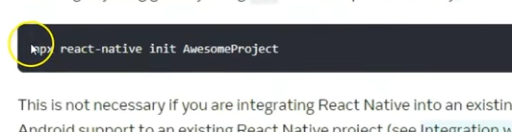
Now the teacher will show you what will you see when you create your react native app.
Teacher is showing this cammand to make a create a react app according to his time
but nowadays it is
npx @react-native-community/cli@latest init <AppName>
The environment setup criteria was same
but the files you saw or the extenstion you see are changed
means prevuisly you used to see jsx but no you ill see tsx
____________________________________
New discovery:-
If you write javascript code in Typescript file then the React native will still work.
____________________________________

Environment setup is still the same

In future the teacher will tell us some basics of Typescript after 30-40 lessons which is enough for react native so that you can use react native with Typescript
and the teacher will tell us typescript you can use with javascript(or maybe in place of).
If you want to still work with javascript then the teacher will tell us way to do it.
The teacher make a new project and now inside the project
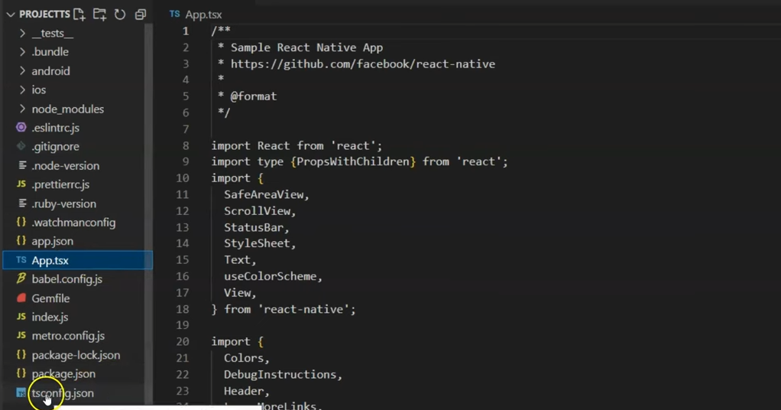
Now you can see the file App.tsx
there is a file named tsconfig.json as you can see the area where the pointer is
This is actually a Typescript configuration file maybe defining the typescript who knows
typescript file is loosely coupled
if you do some small mistakes then it will be forgiven we are not strict mode
As there are two modes in Typescript that are:-
- strict mode
- Loosely coupled mode
In package.json you can see the react native version we are using, in the object of dependencies as shown below
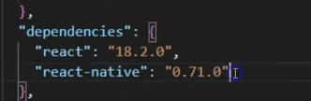
Or
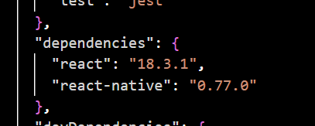
(Newer Version)
Is there difference in the code in the App.tsx from App.jsx file
Yes there is something colon is used followed by type which is not seen in javascript file
and there is type mentioned for variables used which was not possible in javascript
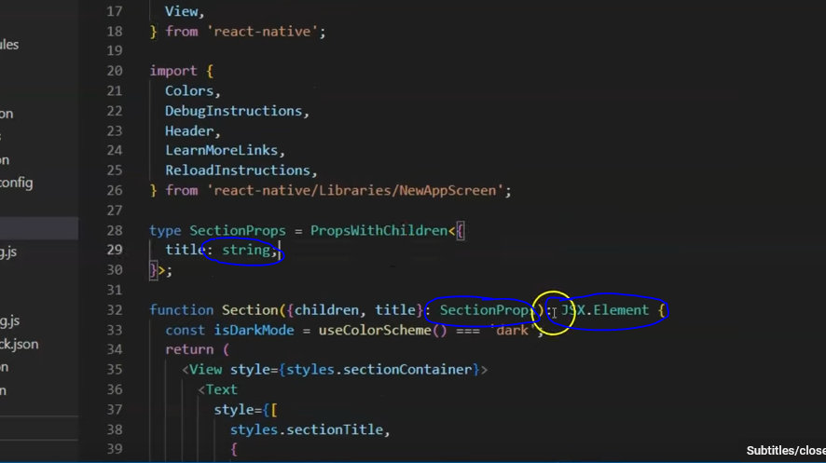
You will observe that it may have given typescript (maybe component) but if you use some javascript in place of typescript by removing colon and type and convert it to javascript then it will still perfectly work .You will not get any problem
we will do the same code which we used in lesson 3 but this time we are not writing the code in App.jsx but in App.tsx so we will convert the typescript code inside it to javascript and it will resembles the js code in lesson 3
Note:-
I think the logic behind the conversion to native code (Java or C Objective) is different for Typescript and Javascript but the end native code will be same(I think so)
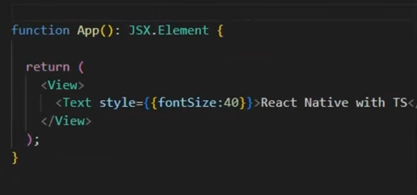
even if you remove JSX.Element then it will still work

To check If it is working as same as previously then we will run it and see the effect of changes in the output

Now if i change the extension .tsx to .jsx and the typescript code remains the same then our app still will work
So you don't have to worry that typescript has arrived and we have to read it for once you can go with javascript also . Everythign works perfectly
Now it is one thing
Now second thing is that we don't even want to see these type script file we want that it should remain javascript then how to do so we will create a new project but htis time you need to define our version and the version should be 0.70 or below it

you can use the cammand below

npx @react-native-community/cli@X.XX.X init AwesomeProject --version X.XX.X

You can modify the command to create a React Native project with version 0.70.0 like this:
npx @react-native-community/cli@latest init AwesomeProject --version 0.70.0
This ensures that the project is initialized using React Native 0.70.0 while using the latest version of the React Native CLI.
Now our new project has js files instead of ts

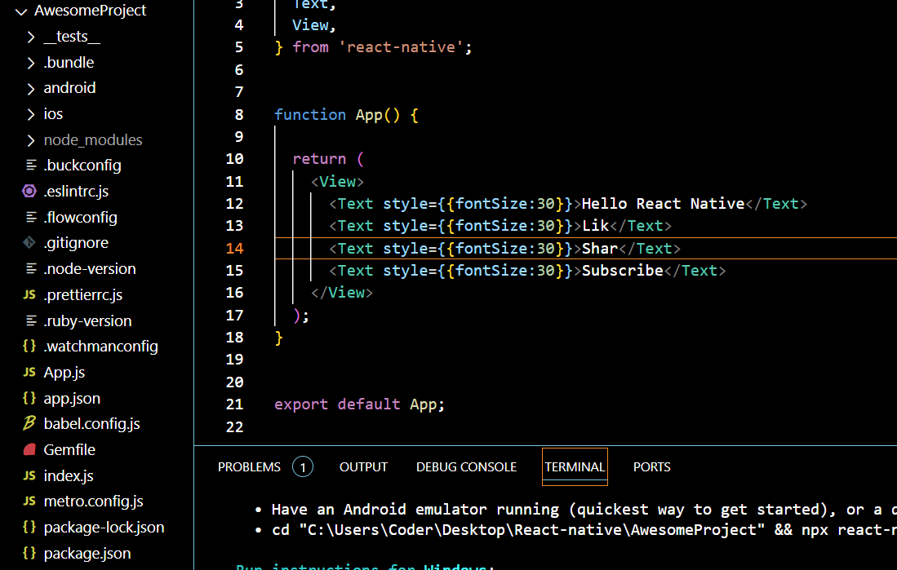
But latest version come with ts by default

Whenever i run my npm run android in VS code then i get this error

npm : File C:\Program Files\nodejs\npm.ps1 cannot be loaded because running scripts is disabled on this
system. For more information, see about_Execution_Policies at https:/go.microsoft.com/fwlink/?LinkID=135170.
At line:1 char:1
+ npm run android
+ ~~~
+ CategoryInfo : SecurityError: (:) [], PSSecurityException
+ FullyQualifiedErrorId : UnauthorizedAccess
Now o solve it follo th step given by AI

The error you're seeing is due to PowerShell's Execution Policy on Windows, which prevents the execution of certain scripts, including npm.ps1 scripts used by npm. By default, PowerShell has a restrictive execution policy to prevent potentially harmful scripts from running.
To resolve this issue, you'll need to change the execution policy to allow scripts to run. Here’s how to do that:

Steps to Fix the Issue:
- Open PowerShell as Administrator:
  - Right-click on the Start menu and select Windows PowerShell (Admin) or search for PowerShell and select "Run as Administrator."
- Check the Current Execution Policy (optional): Before changing the policy, you can check the current execution policy by running the following command in PowerShell:
Get-ExecutionPolicy
- Change the Execution Policy: Run the following command in the Administrator PowerShell window to allow scripts to run:
Set-ExecutionPolicy RemoteSigned -Scope CurrentUser
  - RemoteSigned: This policy allows local scripts to run, but requires scripts downloaded from the internet to be signed by a trusted publisher. This is a safer setting.
  - -Scope CurrentUser: This limits the change to the current user (so it doesn't affect other users on the machine).
- Confirm the Change: After running the above command, PowerShell will ask for confirmation. Type Y and press Enter to confirm the change.
- Try Running the Command Again: Now that the execution policy is updated, you should be able to run your npm command again:
npm run android

Additional Information:
- Execution Policies: Execution policies in PowerShell control the conditions under which PowerShell scripts can run. The available options are:
  - Restricted: No scripts can run (default for most Windows systems).
  - AllSigned: Only scripts signed by a trusted publisher can run.
  - RemoteSigned: Local scripts can run, but remote scripts need to be signed by a trusted publisher.
  - Unrestricted: All scripts can run (this is not recommended for security reasons).
By setting the policy to RemoteSigned, you're ensuring a balance between security and functionality, as it only blocks unsigned remote scripts.

Conclusion:
After updating the execution policy, try running the npm run android command again. It should now work without the error related to script execution being disabled.
If you do the updates in codes and if you will not see the update in the output then remove it and then again add it in the Device manager(meaning Reinstall it)
and then again run the cammand npm run android
then it will download and install expo on the device and then the your app will be loaded and if after sometme it again does not show updation in emulator then active the emulator nd then press cammand ctrl + M and then developer mod will be on
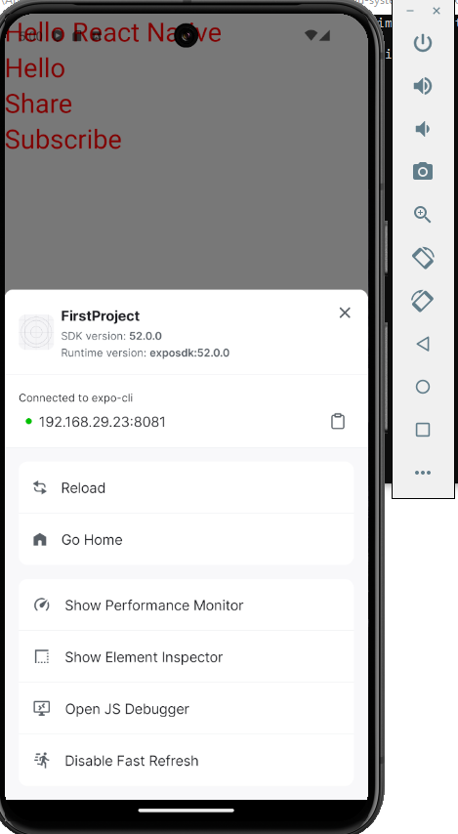
Click on reload then it will be reloaded and then you can see the updation in output if problem repeats again then you can repeat the steps we discussed

Now remove all the typescript code given to you and do some javascript code there then it will still work
Even if you rename the tsx to js or jsx then it will still work.
There is no tenstion that Typescript has come and now we need to study typescript you can go wwith javascript everything is going to work perfectly
Now if we still does not want to see these typescript files we just and that it should be Javscript
SO for that we need to make a new project with a version below 0.71
whatever way the techer istelling to bring js file is not working but i have found which may work
so the cammand is
npx create-expo-app –template
IN Template choose Blank and then tell your app name no youar app will be formed with js files
and when ever you run an app then it is oprened in local ip
which ill be mentioned when you run the cammand
npm run android
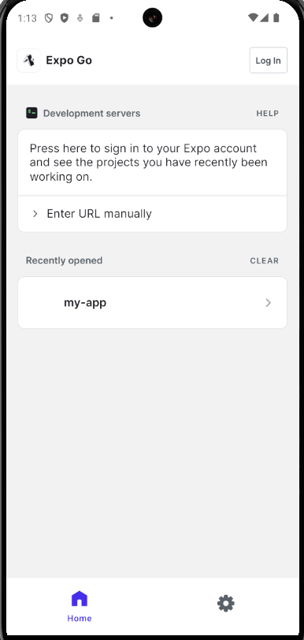
and the url will be mentioned in the cammand line
Now whenever expo app is opened mnually not by cammand then it may give you recetly opened app
but you can go to enter url manually and then enter mentioned in the cammand line

